Public Notice of Rights under Title VI

NOTICE TO THE PUBLIC:
YOUR RIGHTS UNDER TITLE VI OF THE CIVIL RIGHTS ACT
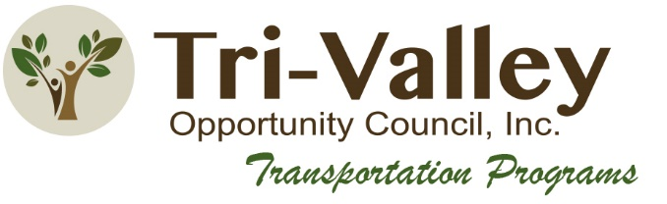
The Tri-Valley Opportunity Council, Inc is committed to ensuring that no person is excluded from participation in, denied the benefits of, or otherwise subjected to discrimination on the basis of race, color, or national origin under any program or activity receiving Federal financial assistance without regard to whether specific projects or services are federal funded. Transit programs and services are distributed in accordance with Title VI of the Civil Rights Act and related nondiscrimination authorities. Additionally, Tri-Valley Opportunity Council, Inc is committed to ensuring that its programs incorporate access for people with limited English proficiency.

Any person who believes that they, individually, or as a member of any specific class of persons, have been subjected to discrimination on the basis of race, color, or national origin may file a discrimination complaint with Tri-Valley Opportunity Council, Inc using the complaint form located on Tri-Valley Opportunity Council, Inc’s website. Tri-Valley Opportunity Council, Inc website is: http://www.tvoc.org

Complaints can be submitted directly to Tri-Valley Opportunity Council, Inc and/or to the Minnesota Department of Transportation (MnDOT), Office of Civil Rights, MS 170, Attention: Title VI Program, 395 John Ireland Blvd, St. Paul, MN 55155

Alternatively, a complaint may be directly filed with the Federal Transit Administration by filing a complaint with the Office of Civil Rights, Attention: Title VI Program Coordinator, East Building, 5th Floor-TCR, 1200 New Jersey Ave., SE, Washington, DC 20590

If you need information translated into another language, or require information in an alternative format, please contact Elizabeth Hensrud 1345 Fairfax Ave Crookston, MN 56716 elizabeth.hensrud@tvoc.org.

For more information about Tri-Valley Opportunity Council, Inc Title VI Program, and the procedures to file a complaint, please reference the Language Assistance Plan, and Appendix H: Title VI Complaint Procedure located on Tri-Valley Opportunity Council, Inc website, under https://www.tvoc.org/services/transportation/title-vi-notice-to-public/ by phone 800-201-3432 email thebus@tvoc.org or visit our administrative office at 1345 Fairfax Ave Crookston, MN 56716.

_____________________________________ _____________________
Cynthia Pic, Transportation Programs Director Date
Tri-Valley Opportunity Council, Inc

