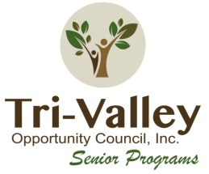
Tri-Valley Senior
Programs
Tri-Valley Opportunity Council, Inc. · 102 North Broadway · P.O. Box 607
Crookston, MN 56716 · 218-281-5832 · 800-584-7020 · Marley.Melbye@tvoc.org

Polk County 2022 Outstanding Senior Citizen Award

- The nominee must be a resident of Minnesota.
- The nominee’s volunteer service must be accomplished after reaching age 65.
- Nominee must be age 70 by June 1 of the current year.
- Nominee must currently do a volunteer activity that is unpaid and demonstrates
commitment to their local community.
- A previous county winner not chosen as the state winner is eligible. However, a
current year’s nomination form must be completed.
- You may only nominate one individual per nomination form.

Nominee Name: Click or tap here to enter text.  Date of Birth: Click or tap here to enter text. | Nominated by: Click or tap here to enter text.
Address:Click or tap here to enter text.  County: Click or tap here to enter text. | Address: Click or tap here to enter text.
Home Phone: Click or tap here to enter text.  Cell Phone: Click or tap here to enter text. | Home Phone: Click or tap here to enter text.  Cell Phone: Click or tap here to enter text.
Current/ Previous Occupation: Click or tap here to enter text.
How do you know the nominee: Click or tap here to enter text.

Volunteer Accomplishments: Click or tap here to enter text.

Signature: Click or tap here to enter text. Date: Click or tap to enter a date.
Please submit completed application to Marley Melbye via email at marley.melbye@tvoc.org or mail application to Crookston MN Tri-Valley at PO Box. If you have questions call Marley at 218-281-5832.

